**Project Documentation**

**RhythmicTunes: YourMelodic Companion**

**1.Introduction**

**Project** **Title**: **RhythmicTunes: Your Melodic Companion**

* **Team ID:NM2025TMID31591**
* **Team Leader:**

➢ NAME: SWETHA M

MAIL ID: [swethamano41106@gmail.com](mailto:swethamano41106@gmail.com)

❖ **Team Members**

* NAME: NITHYA K

MAIL ID: nithyakanagaraj2111@gmail.com

* NAME: MATHUMATHI V

MAIL ID: vgmathumathi@gmail.com

* NAME: LAVANYA L

MAIL ID: lokul0521@gmail.com

# 2. Project Overview

* **Purpose:** RhythmicTunes: Your Melodic Companion empowers professionals and organisational to navigate emerging trends, share real time insights , and adapt to evolving business landscape through collaborative learning, analysis and communication

❖ **Features:**

* Melodic Companion
* Secure chat system
* Feedback and review system
* Admin control panel

**3. Architecture**

Frontend: React.js with Bootstrap and Material UI

# 4. Setup Instructions

❖ **Prerequisites:**

* Node.js
* Git
* React.js
* Express.js – Visual Studio Code

❖ **Installation Steps:**

# Clone the repository git done

#install client dependencies cd

Client npm install

# Install server dependencies cd

../server npm install

# 5. Folder Structure

SB-Works/

|-- client/ # React frontend

|__components/

L__ pages/

# |__ server/ # Node.js

# 6.Runningthe Application

❖ **Frontend:**

* cd client
* npm start

❖ **Access: Visit** [**http://localhost:3000**](http://localhost:3000/)

# 7. API Documentation

❖ **User:**

1. /api/user/register • /api/user/login
2.  **Projects:**
3. /api/projects/create
4. /api/projects/:id • Applications: /api/apply

❖ **Chats:**

* /api/chat/send
* /api/chat/:userId

# 8. Authentication

* **JWT-based authentication for secure login**
* **Middleware protects private routes**

# 9. User Interface

* Landing Page
* Freelancer Dashboard
* Admin Panel
* Project Details Page

# 10. Testing

* Manual testing during milestones
* Tools: Postman, Chrome Dev Tools

# 11. Screenshots

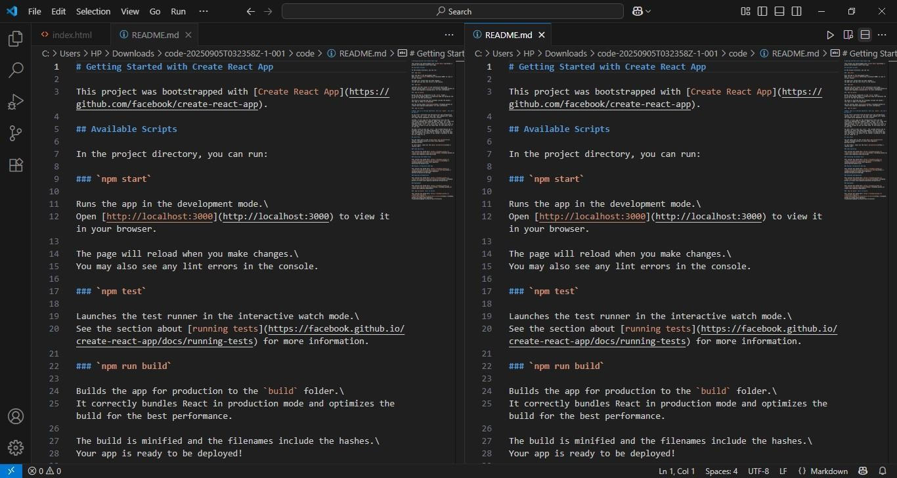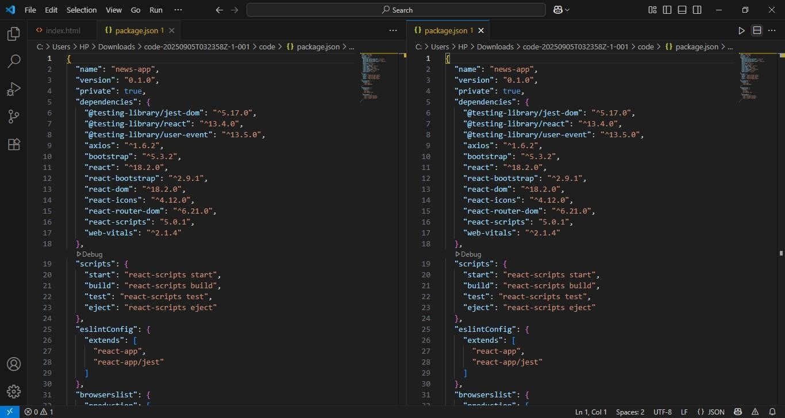

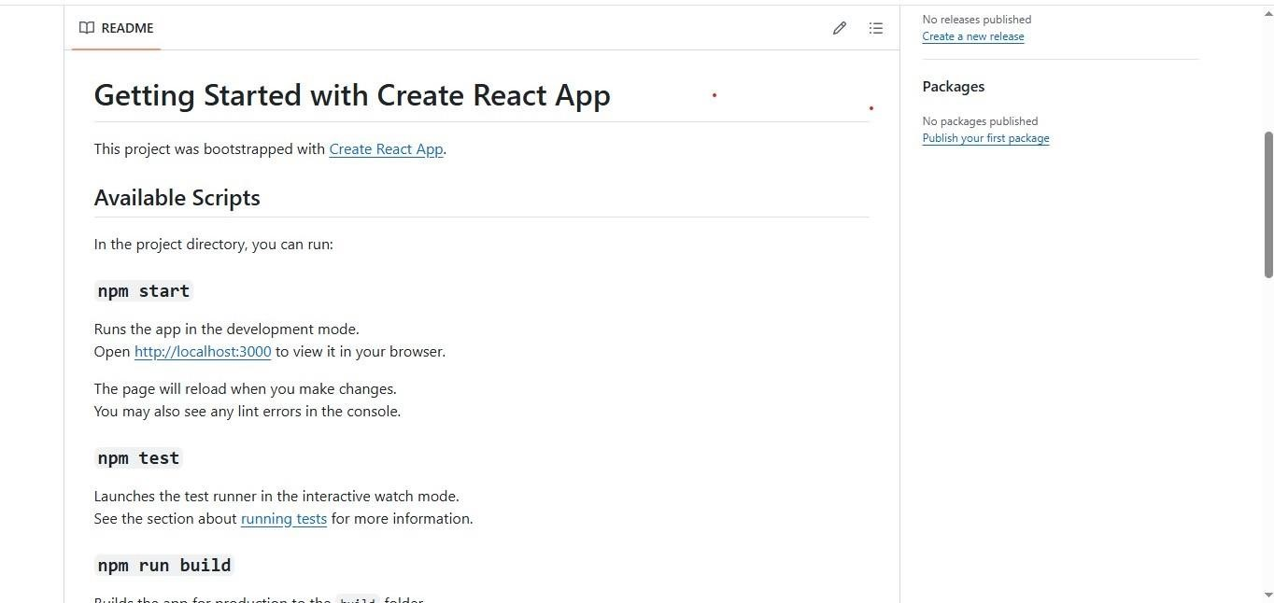

1. Known **Issues**
   * API Rate Limits
   * Server Problem
   * Navigation Glitches
2. Future Enhancements
   * Analytics Dashboard
   * Search Functionality
   * User Authentication